**ASSESSMENT INSTRUCTIONS**

Welcome to IIHT’s Assessment Platform …..

**Step 1: System/PC Configuration prerequisites to be checked by the USER.**

1. Are you are using the latest version of the browser. We recommend using Google Chrome.

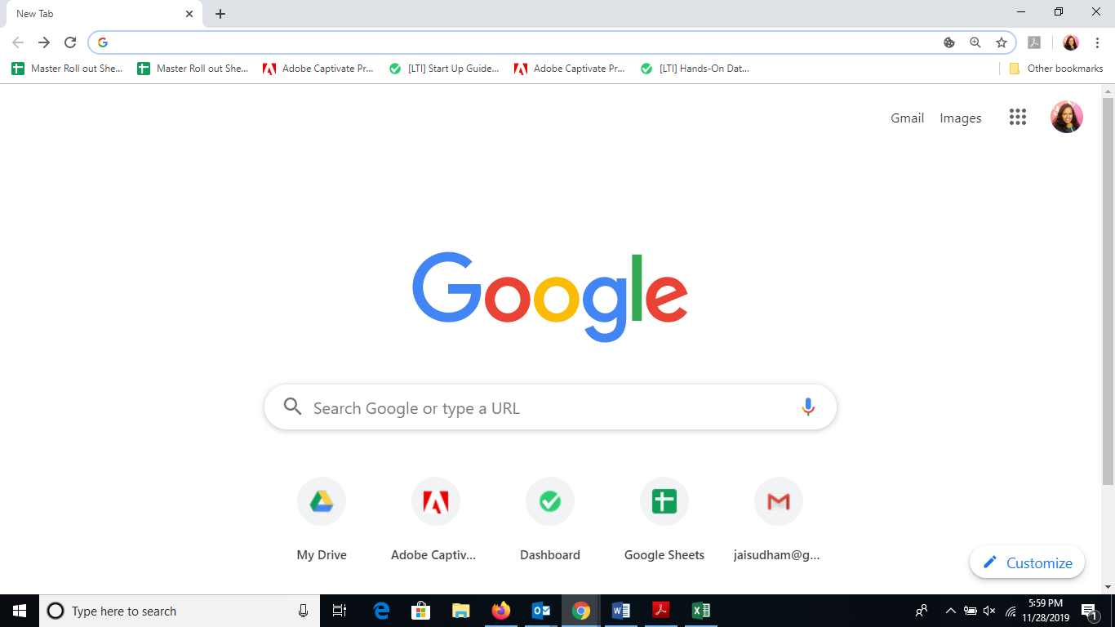

1. It's mandatory to disable all the browser extensions and enabled Add-ons

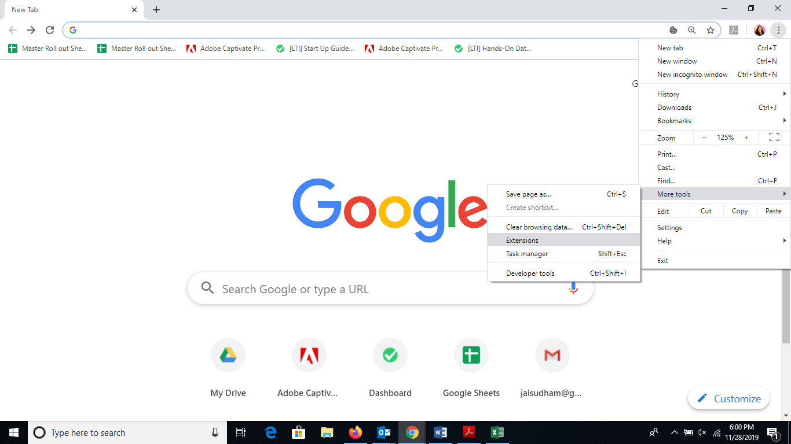

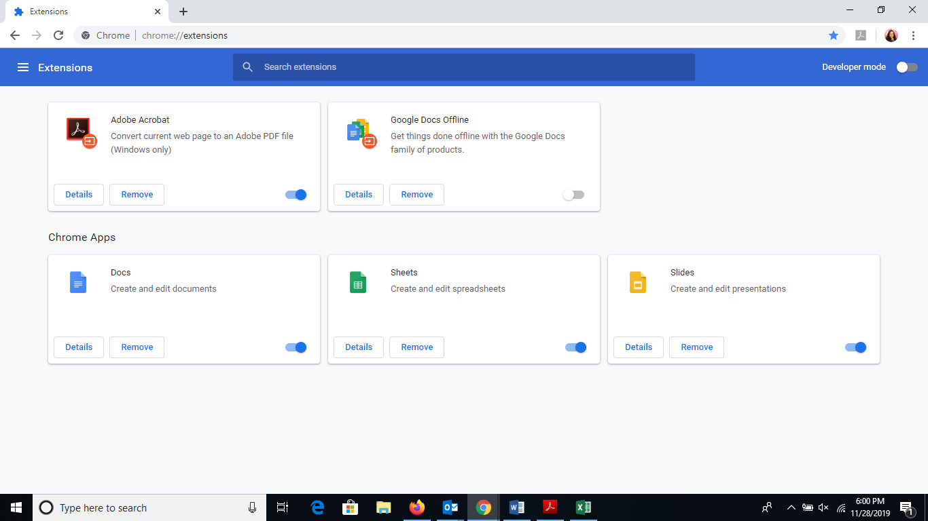

Repeat steps for every add-on

1. **Open the test in incognito mode.**

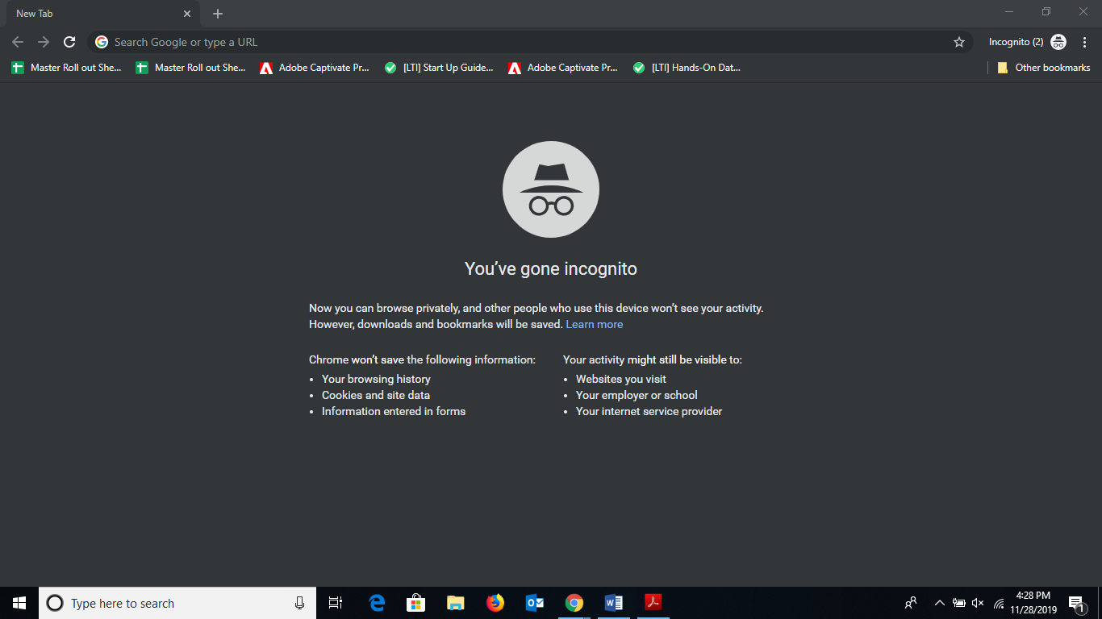

**Step 2: Login to Assessment Platform.**

1. From the Portal click on the go to Activity URL which leads to Assessment Engine

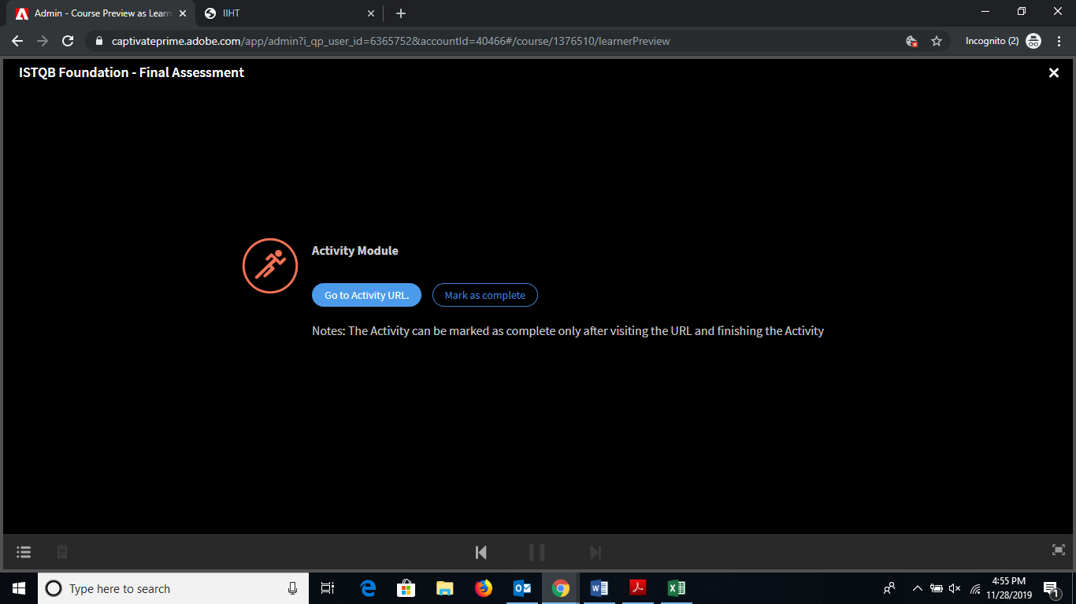

1. Do-select Portals Launches

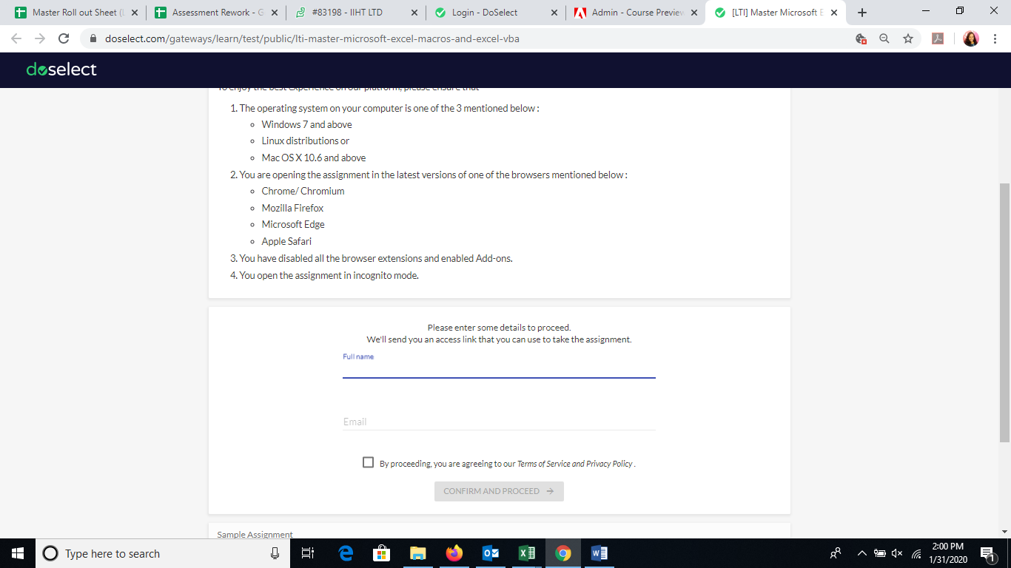

1. Enter the Login Information user name and Email ID.
2. Check the Terms and services check box and click on **Confirm and Proceed** button.

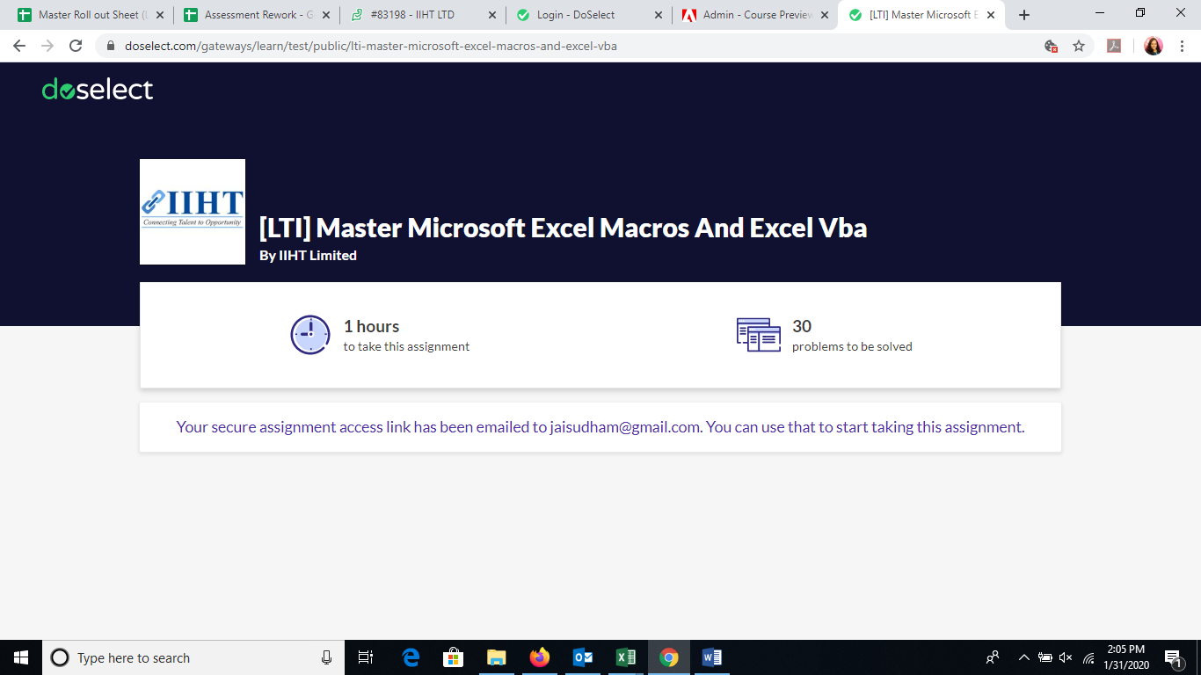

1. An email link will be received on the mentioned mail id .kindly click on **Go TO Assignment** button

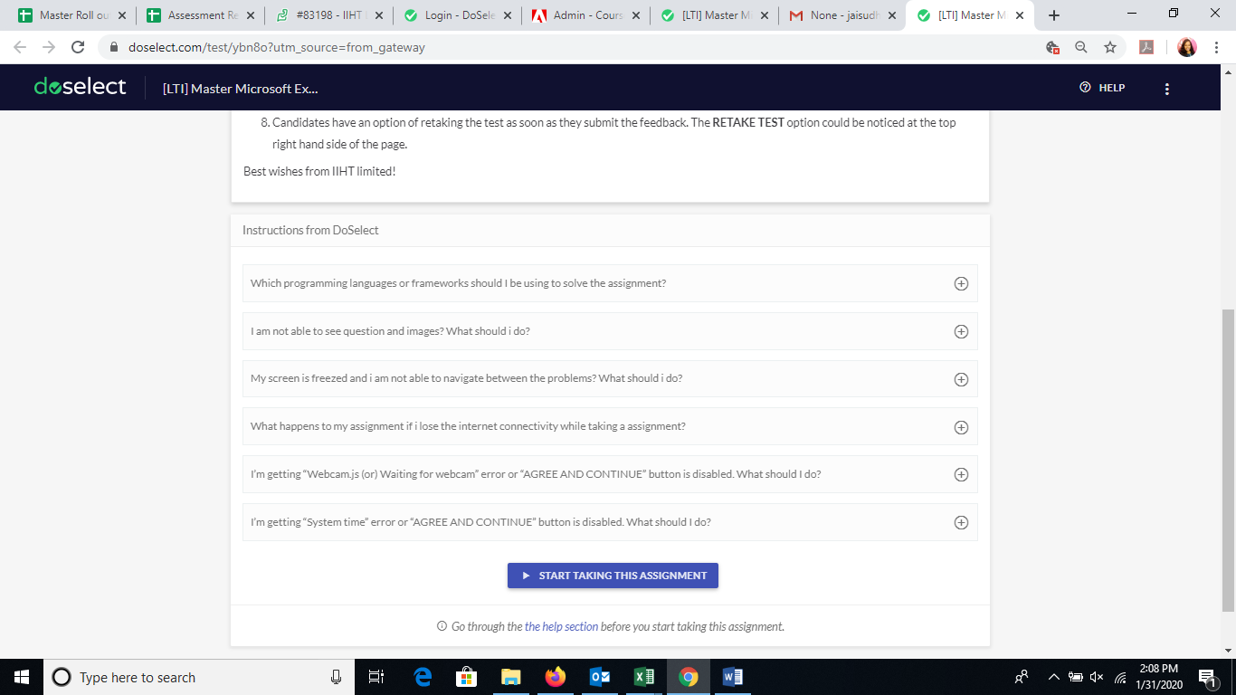

1. Click on **START TAKING THIS ASSIGNMENT**.

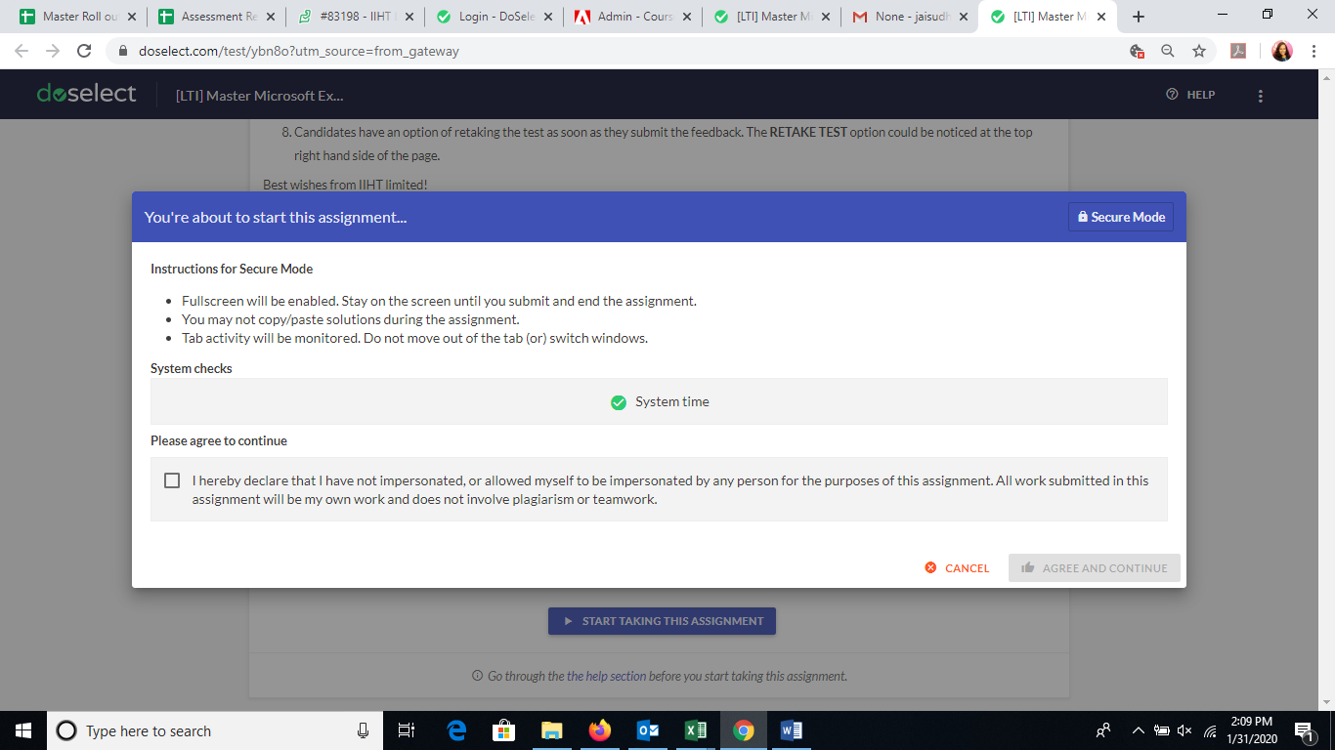

1. Check the declaration check box and click on **Agree and Continue**.

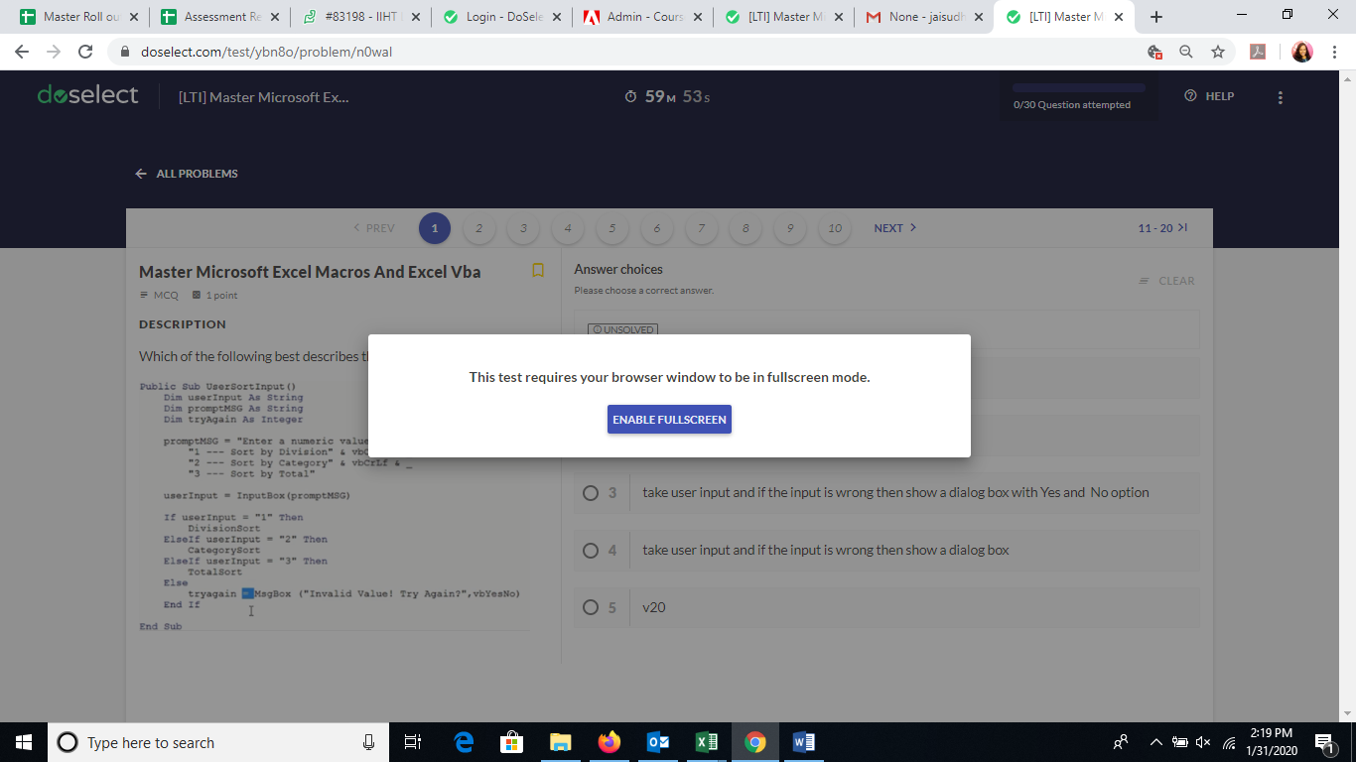

1. Click on **ENABLE FULLSCREEN.**
2. Duration of the Assessment would be varying from Assignment to Assignment. However, this will be available for the user in the Assessment Home Page.
3. The Assessment Timer will start, when the USER starts the Assessment. The Assessment will be Auto Submitted, as soon as the Timer count ends.
4. Candidate has to finish the complete test in one go. The User can’t pause the Timer during the session.

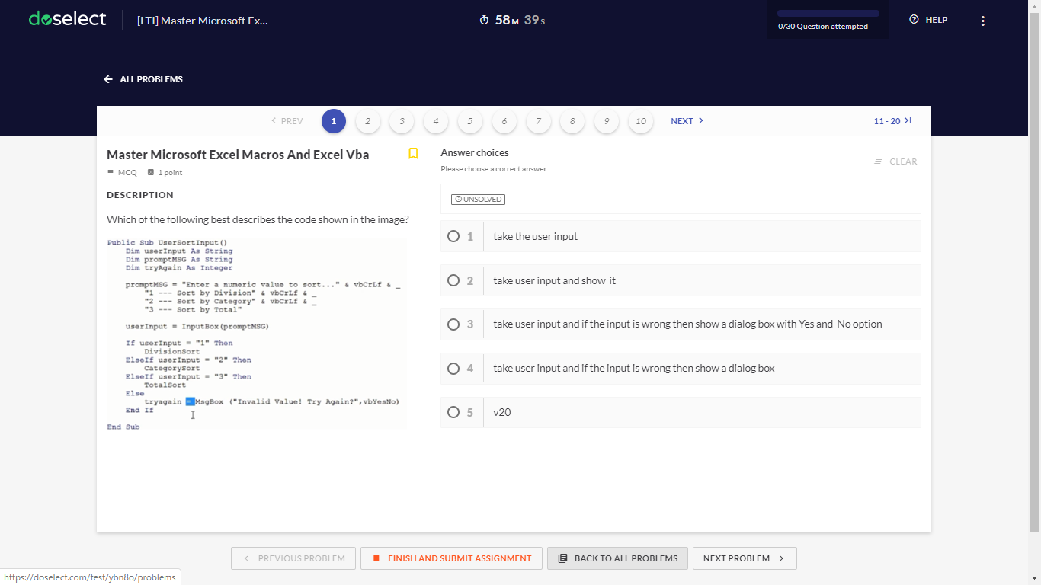

12.Candidates can Submit the Assessment on clicking **FINISH AND SUBMIT ASSIGNMENT** button.

**BEST WISHES FROM IIHT !!!!**